**UNIT 2: Shopping**

Part 1: Describe the Pictures

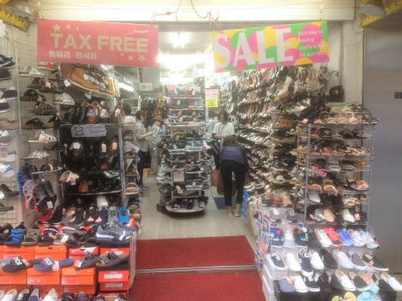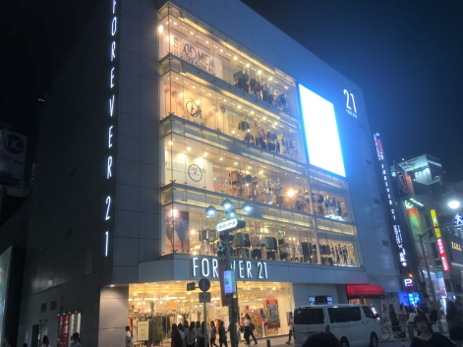

Part 2: Reading and Vocabulary

Many people like to go shopping in their favourite retailers. You can choose from a large selection of products and pay at the till. Twice a year shops usually have sales where the prices are lowered and you can get good bargains. You can spend money on things that you want. Some people go on a spending spree and buy many items. It is a good idea to keep your receipt and see if you have been short-changed by accident. Keeping your receipt is also good because sometimes the products can be faulty and you have to take them back and complain to the retailer and they can change them.

You don't have to buy anything at a retailer; you can just go for window shopping.

Part 3: Match the Vocabulary

|  |  |
| --- | --- |
|  | a low-priced product |
|  | use money |
|  | shop |
|  | paper you get when you buy something |
|  | broken/damaged |
|  | place where you pay |
|  | spend a lot of money |
|  | just looking in a shop |
|  | tell someone you are not happy with something |
|  | get less change than you should have |

Part 4: Fill in the gaps with the correct form from the new words above

1) I chose what I wanted and went to the __________________ to pay.

2) In the new year you can get good __________________.

3) There is a good electrical __________________ on the high street.

4) When I get my salary I __________________ clothes.

5) I looked at my receipt and found I had been __________________.

6) He won the lottery and went on a __________________.

7) When you buy something make sure you get a __________________.

8) She didn't buy anything, she just went __________________.

9) The watch I bought was __________________.

10) I was so angry I __________________ about the service in the shop.

Part 5: Ask and answer with your partner:

1) Do you enjoy shopping? Why/why not?

2) What is your favourite **retailer**?

3) Have you ever shopped online?

4) What is the best item you have ever bought?

5) Have you ever been **short-changed**?

6) Do you prefer shopping alone or with friends?

7) Where is the best/worst place to shop in your country?

8) What products are cheap/expensive to buy in your country?

9) What do you dislike to shop for?

10) Do you ever go **window shopping**?

11) If you could go shopping anywhere in the world, where would you go?

12) When you get to the **till** how do you usually pay?

13) When you buy something, do you usually check your **receipt**?

14) If you won a million pounds, what would you **spend** it **on**?

15) What's the most expensive thing you have ever bought?

16) Have you ever bought **faulty** goods?

17) Have you ever **complained** in a shop?

18) What's the biggest shop in your country?

19) When is a good time to get **bargains** in your country?

20) What have you bought this week?

21) Have you ever been on a **spending spree**?

*Extension: write 4 questions about this topic to ask your partner.*

22)

23)

24)

25)

Part 6: Write the Questions

1) ________________________________________________________________________?

My favourite retailer is in the high street.

2) ________________________________________________________________________?

I'm sorry, I don't know where the till is.

3) ________________________________________________________________________?

A good time to get a bargain is after Christmas.

4) ________________________________________________________________________?

I usually spend most of my money on food.

5) ________________________________________________________________________?

Yes, I have been on a spending spree twice.

6) ________________________________________________________________________?

Yes, I always check my receipt.

7) ________________________________________________________________________?

No, I have never been short-changed.

8) ________________________________________________________________________?

If the product is faulty, you should take it back.

9) ________________________________________________________________________?

The best person to complain to is the manager.

10)_______________________________________________________________________?

Yes, I sometimes go window shopping.