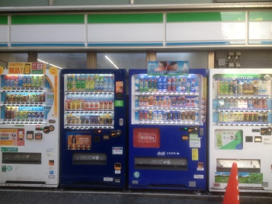**Past Tense (Irregular)**

For irregular past tense verbs, you must learn them!

These are all irregular:

|  |  |  |  |  |  |  |  |
| --- | --- | --- | --- | --- | --- | --- | --- |
| **Verb** | **Past** | **Verb** | **Past** | **Verb** | **Past** | **Verb** | **Past** |
| Buy |  | Go |  | Make |  | Sleep |  |
| Can |  | Have |  | Meet |  | Speak |  |
| Do |  | Is |  | Pay |  | Stand |  |
| Drink |  | Know |  | Read |  | Take |  |
| Eat |  | Leave |  | See |  | Write |  |

*First change these words to the* ***past*** *then put them in the spaces:*

meet/drink/go/speak/see/write/buy/pay/leave/eat/

1) I __________ to the park yesterday.

2) He __________ beer in the pub last night.

3) She __________ a letter to her boyfriend.

4) They __________ fish and chips in the park.

5) She __________ on the phone for a long time.

6) He __________ his friends at the pub last Saturday night.

7) Mary __________ a bottle of wine in the supermarket.

8) Linda __________ college late last night.

9) When I was in the park, I __________ a cat.

10) I __________ a lot of money for my new shoes.

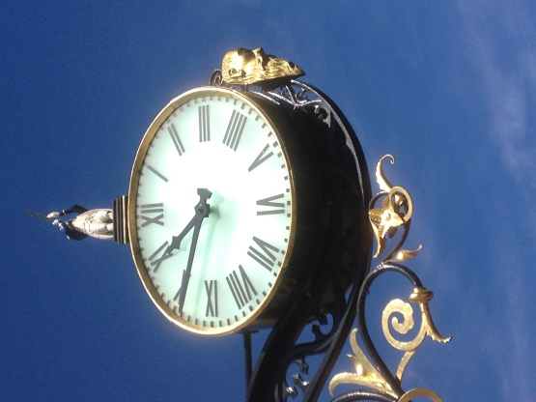**Past Questions**

*Put these words in the correct order to make questions:*

1) did/do/what/you/morning/this?

2) you/what/did/yesterday/do?

3) did/what/do/Saturday/you/last?

4) what/do/did/Sunday/you/last?

5) did/breakfast/you/what/yesterday/eat/for?

6) lunch/did/what/for/you/eat/yesterday?

7) did/what/you/for/dinner/eat/yesterday?

8) you/what/did/drink/yesterday?

9) did/who/yesterday/you/meet?

10) go/where/did/you/last/summer?

11) time/what/you/did/up/get/yesterday?

12) did/what/you/to/time/last/go/night/bed?

*Extension – make 5 more past questions to ask your partner:*