**Past Crossword**

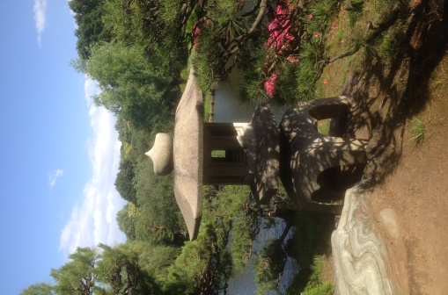  
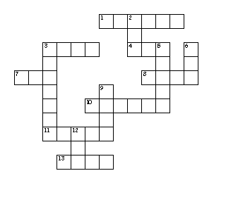

**Across**

1. I _____ my dirty clothes yesterday

3. They _____ shopping yesterday

4. I _____ very tired after work

7. I _____ my friend in the park

8. I _____ a good book last night

10. She _____ a cake in the shop

11. The man _____ beer in the pub

13. They _____college after class

**Down**

2. He _____ a cat in the street

3. I _____ TV last night

5. He _____ for 8 hours last night

6. She _____ a headache last night

9. He _____ a train to Richmond

12. We _____ fish and chips last night