**UNIT 1: House and Home**

Part 1: Describe the Pictures

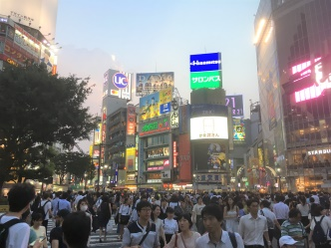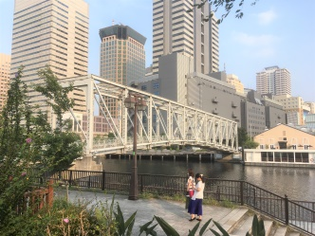

Part 2: Reading and Vocabulary

Many people are proud of their homes. The traditional working class home was a cottage with two rooms upstairs and two rooms downstairs. Another type is a semi-detached house with its two reception rooms, kitchen and three bedrooms. There are many of these in the suburbs and people commute to the city centre from here. Property is expensive in the city.

Traditionally, some people didn't like to reside in flats and high-rise buildings. However, now they are more popular and are more expensive to purchase.

Many houses have a garden with a green lawn. Recently, because of a generally more hectic lifestyle, people now favour low maintenance gardens. One of the drawbacks to owning your own home is that things often go wrong. DIY (do it yourself) is very popular because it is expensive to get tradesmen. Many people do their own painting and decorating.

Part 3: Match the Vocabulary

|  |  |
| --- | --- |
|  | buy |
|  | area of grass cut short |
|  | small house |
|  | travel regularly from home to work |
|  | workman |
|  | house or flat |
|  | area outside the city centre |
|  | live |
|  | disadvantage, problem |
|  | busy and rushed |

Part 4: Fill in the gaps with the correct form from the new words above

1) Most of the properties in this town are __________________.

2) People are often too busy to cut the __________________.

3) Getting a __________________ to do repairs can be very expensive.

4) These days more people like to __________________ in flats.

5) John __________________ to work from his home in the suburbs.

6) The price of __________________ is high in good areas.

7) The pace of life these days is very __________________.

8) The __________________ are often green with large open spaces.

9) __________________ a residence in London can be expensive.

10) There are a number of __________________ to living in the city centre.

Part 5: Ask and Answer with Your Partner:

1) Where do you live?

2) Do you like where you live? What do you like/dislike about it?

3) How many rooms do you have? Describe your home.

4) What is your home near? Describe the area around your home.

5) Is your area a **hectic** place to live in?

6) Which room do you like best? Which room do you use the most?

7) Do you have a garden? Describe your garden if you have one? Does it have a **lawn**?

8) How far do you **commute** from your house to work?

9) What are your neighbours like?

10) If you could live anywhere in the world, where would you live?

11) Describe your dream **property**.

12) Where is the best place to **reside** in your country?

13) How much does it cost to **purchase** a house in your country? How much is renting?

14) Would you prefer to live in a **cottage**, house or flat? Why?

15) What are the advantages and disadvantages of living in the city/countryside?

16) Which is preferable for you to live in, the CBD or the **suburbs**?

17) Which do you like better, your accommodation here or in your own country?

18) Would you like to make any improvements to your home? If so, what?

19) Do you do DIY or do you get **tradesmen**?

20) What are the **drawbacks** to owning your own home?

21) How long do you intend to stay in your present accommodation?

*Extension: write at least 4 questions about this topic to ask your partner.*

Part 6: Write the Questions

1)________________________________________________________________________?

A cottage usually has two bedrooms.

2)________________________________________________________________________?

I would like to live in the suburbs.

3)________________________________________________________________________?

I spend two hours commuting every day.

4)________________________________________________________________________?

Property is most expensive in the city.

5)________________________________________________________________________?

I reside in the city centre.

6) ________________________________________________________________________?

I purchased my house in 1995.

7) ________________________________________________________________________?

I use a lawnmower to cut the lawn.

8) ________________________________________________________________________?

Yes, I do have a hectic life.

9) ________________________________________________________________________?

Pollution is one of the drawbacks to living in the city.

10)_______________________________________________________________________?

You usually need a tradesman when you have problems with your house.