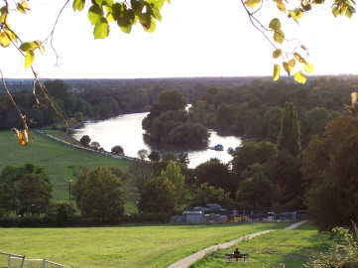**Useful Vocabulary 2**

*Match the words with their definitions:*

|  |  |
| --- | --- |
|  | Person who helps/supports you |
|  | Ridiculous in an amusing way |
|  | Stick/attach firmly to something |
|  | Use something/someone for a purpose |
|  | Weak/very little strength |
|  | On time |
|  | Particular and distinctive smell |
|  | Disaster |
|  | Become worse in condition/quality |
|  | Enemy |
|  | Productive |
|  | Cure/solution |
|  | Pierce/make a small hole in something |
|  | Strong disapproval/disagreement of something |
|  | Rarely |
|  | Home |
|  | Boring |
|  | Fat/solid |
|  | Connected with city |
|  | Walk around for pleasure |
|  | Done quickly |

|  |
| --- |
| absurd adhere ally calamity  deteriorate employ feeble fertile  foe odour oppose prompt  punctual puncture ramble remedy  residence seldom stout tedious urban |

****Exercise**

*Put the new words into the gaps in the correct grammatical form:*

1) Many people _______________ the terrible new development on the seafront.

2) Losing the match was an absolute _______________ for the team as they had been a very ambitious side.

3) Having not eaten for days, his health started to_______________.

4) Java in Indonesia has very _______________ soil; anything can grow there.

5) They _______________ on the hiking trails in the barren wilderness.

6) Sitting at home all day can be very _______________.

7) There was a terrible _______________ coming from the loft.

8) Far from being foes, the USA and the UK are strong _______________.

9) Jake was a model pupil; he always _______________ to the rules.

10) Ralph _______________ servants to do the domestic chores as he was too idle.

11) Foxes can often be seen in the _______________ environment.

12) The tranquil silence was _______________ by a loud boom.

13) He perished because a _______________ could not be found.

14) The thought of him wearing a clown costume to the dinner party was ______________.

15) Jean was a prosperous pioneer who lived in a palatial _______________ in rural England.