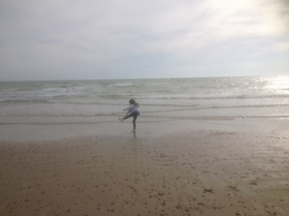**Useful Vocabulary 1**

*Match the words with their definitions:*

|  |  |
| --- | --- |
|  | Send someone away and not allow to return |
|  | Short |
|  | Want to get to the top |
|  | Make someone believe something untrue |
|  | Hug |
|  | Nothing can grow there |
|  | Give all of your time/energy to something |
|  | Force someone to do something |
|  | Loud and unpleasant long-lasting noise |
|  | Choose a representative |
|  | Feel very sad about something that happened |
|  | Connected with a house |
|  | Great danger |
|  | Connected with countryside |
|  | Someone who buys and sells goods |
|  | Die from hard conditions |
|  | Lazy; not working |
|  | First person to do something |
|  | Container/ship |
|  | Sea journey |
|  | Wealthy |

|  |
| --- |
| ambitious banish barren brief  compel deceive devote din  domestic elect embrace grieve  idle merchant peril perish  pioneer prosperous rural vessel voyage |

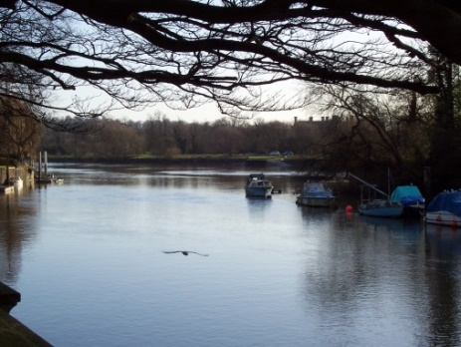**Exercise**

*Put the new words into the gaps in the correct grammatical form:*

1) _______________ life is much more tranquil than urban life.

2) The _______________ set sail on her maiden voyage.

3) The peninsula was totally _______________; nothing grew at all.

4) Tim’s speech was very _______________; it was over in two minutes.

5) At the children’s party there was such a _______________ that the police were called by anxious neighbours.

6) The discovery of precious metal made them very _______________.

7) As Paula had done absolutely no work the whole holiday, her mum called her _______________.

8) He was an _______________ boy who wanted to get to the top.

9) After hearing about the death of her kitten, Erica _______________ for over a week.

10) Mum does all the _______________ chores while dad goes out to work.

11) Due to the political scandal, the people _______________ a new president.

12) Colin was a prosperous _______________ who sold his wares to many consumers.

13) The couple _______________ for the last time as Lilly was about to board the train.

14) Although he was reluctant, David was ______________ to study maths every day.

15) The Wright brothers were _______________ in their field. They went on to invent the aeroplane.