**UNIT 5: Money**

Part 1: Describe the Picture

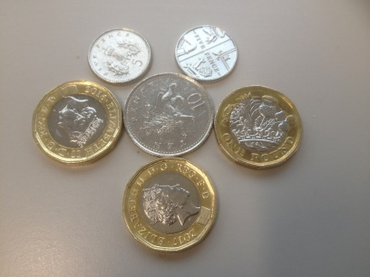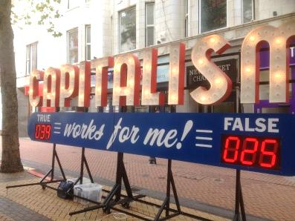

Part 2: Reading and Vocabulary

These days life has become very expensive. The cost of living is usually highest in the capital city of a country. It is a good idea to have a budget to help you plan how you spend your money. Some people don't have a budget and spend all their money and become broke.

If you want something that you can't afford, you can save money in a bank or invest it. Some people like to invest their money by buying shares in companies. When they sell shares they hope to get more money than they paid for them and make a profit. If they make a lot of money, then they will become wealthy. If they lose money, then we say that they have made a loss.

Another way to become wealthy is by inheriting money when someone dies. This money is usually from a family member.

There are many charities and people often donate money to them. These charities can be to help homeless people in this country or poor people abroad.

Part 3: Match the Vocabulary

|  |  |
| --- | --- |
|  | have no money |
|  | rich |
|  | price of living |
|  | make money |
|  | lose money |
|  | give something to someone for free |
|  | get money when someone dies |
|  | don't have enough money |
|  | spending plan |
|  | put money into something |

Part 4: Fill in the gaps with the correct form from the new words above

1) I __________________ my old clothes to a local charity shop last week.

2) His grandfather died and he __________________ a lot of money.

3) The __________________ is very high in my country.

4) He spent all his money and now he is __________________ .

5) She bought shares in a company but she made a __________________ .

6) When the price of his shares went up he made a big __________________ .

7) If I were __________________ , I would buy a big house.

8) She wants a new car but she __________________ to buy one.

9) I __________________ a lot of money in a new company last month.

10) I want to see how I spend my money so I made a __________________ .

Part 5: Ask and answer with your partner:

1) If you won a lot of money, what would you buy?

2) What is the **cost of living** like in your country?

3) What do you spend the majority of your money on?

4) What are the advantages and disadvantages of being **wealthy**?

5) If you saw a homeless person on the street, would you **donate** any money?

6) Have you ever lost or found any money?

7) How would your life be different if you were **wealthy**?

8) What is a good way to make money in your country?

9) Have you ever **donated** money to charity?

10) Who is the **wealthiest** person you know?

11) Do you give yourself a **budget** and do you keep it?

12) Are you saving up for anything at the moment?

13) Have you ever been **broke**?

14) Is it easy to get a bank loan in your country?

15) Do you have a credit card? If so, what do you use it for?

16) Do you know anyone who has **inherited** any money?

17) Have you ever lent money to anyone?

18) If you needed money, who would you borrow it from?

19) Have you ever **invested** any money? Did you make a **profit** or a **loss**?

20) Do you sometimes waste money?

21) What's a good way to save money?

*Extension: write 4 questions about this topic to ask your partner.*

22)

23)

24)

25)

Part 6: Write the Questions

1) ________________________________________________________________________?

The cost of living is highest in large cities.

2) ________________________________________________________________________?

No, I don't give myself a budget when I go on holiday.

3) ________________________________________________________________________?

He became broke when he lost all his money.

4) ________________________________________________________________________?

I can't afford to buy a new house.

5) ________________________________________________________________________?

I usually invest my money in the bank.

6) ________________________________________________________________________?

Yes, I made a big profit.

7) ________________________________________________________________________?

If I was wealthy, I would donate some money to charity.

8) ________________________________________________________________________?

No, I made a loss when I sold the shares.

9) ________________________________________________________________________?

She inherited money from her grandfather.

10)_______________________________________________________________________?

Yes, I sometimes donate money to charity.