****Adverbs 1**

*Match the adverbs with their definition:*

|  |  |
| --- | --- |
|  | Quickly and energetically |
|  | By chance |
|  | Keep forgetting to do things |
|  | Confusing and difficult to understand/choose |
|  | With energetic interest |
|  | Saying “yes”/showing agreement |
|  | On purpose |
|  | Frightening and violent |
|  | Extremely happily |
|  | Taking yourself too seriously |
|  | Completely |
|  | Unsurely |
|  | Angrily |
|  | Exactly and clearly |
|  | Working well |

|  |
| --- |
| absentmindedly affirmatively bewilderingly blissfully  briskly coincidentally crossly deliberately  doubtfully earnestly efficiently enthusiastically  entirely explicitly ferociously |

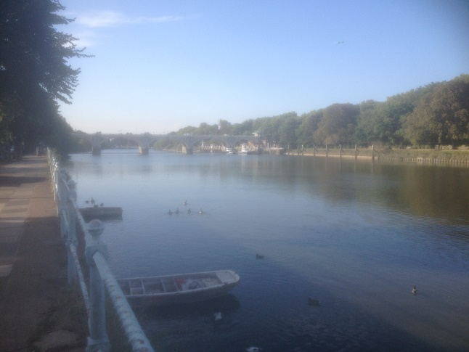**Exercise**

*Insert the most appropriate adverb into the space below:*

1) As he was in a hurry, Basil walked _______________ along the promenade.

2) Steve was very diligent and always studied _______________.

3) German cars have a reputation for working _______________.

4) Although Ralph denied breaking the window, his mother didn’t believe his story and looked at him _______________.

5) They had just tied the knot and were _______________ in love.

6) Winning the lottery was _______________ unexpected.

7) As George hadn’t done the homework, his teacher scolded him _______________.

8) “You’re right!” Simon nodded _______________.

9) Although his mother had ____________ warned him not to go into the water, Dave went against her wishes.

10) Sue was _______________ lost in the maze at Hampton Court.

11) The Doberman barked at the intruder _______________.

12) As Rachel was in a bad mood, she was _______________ obnoxious to Mark.