**Present Simple Tense**

|  |
| --- |
| FORM:  I/You/We/They **walk**; He/She/It **walks**  NEGATIVE FORM:  I/You/We/They **don’t** walk; He/she/It **doesn’t** walk  Use for: Habits/routines |

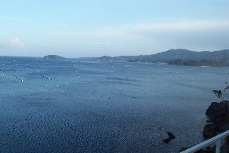

*Change the verbs into to the correct form and put in the gaps:*

1) Steve ________________ driving a taxi (love).

2) Sue ________________ her colleagues at work every day (meet).

3) Roger ________________ well because of the noise (sleep).

4) She ________________ by bus every weekday (travel).

5) Tom ________________ his manager anymore (like).

6) That’s a nice uniform, Rob. You ________________ very nice (look).

7) Ralph ________________ beer at bar every night (serve).

8) Dave ________________ pizza in the restaurant (cook).

9) I love my job. I ________________ about it every day (think).

10) She ________________ wine every night (drink).

11) Linda ________________ sick. She can’t work (feel).

12) I ________________ anymore because I have a bad back (work).

13) My job ________________ at 7 o’clock tonight (start).

14) Adam ________________ very hard (work).

15) Frank ________________ a truck anymore (drive).

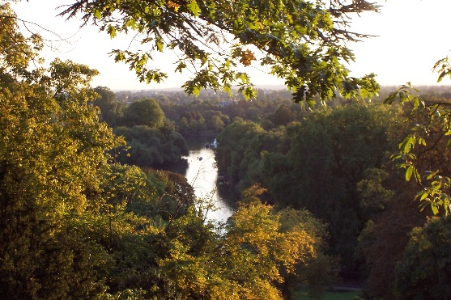**Daily Routines**

Write 12 sentences about your daily routine:

1

2

3

4

5

6

7

8

9

10

11

12

*Extension – write 5 more sentences:*

1

2

3

4

5