**Adjectives 1**

*Match the adjectives with their definition:*

|  |  |
| --- | --- |
|  | Short |
|  | Suitable |
|  | Gives you benefits |
|  | Able to move quickly and easily |
|  | Very simple with no luxury |
|  | Polite/showing respect |
|  | Loveable |
|  | Angry/worried |
|  | Untidy with lots of objects |
|  | In great pain |
|  | Worried |
|  | Proudly refusing to obey |
|  | Helping others even if it causes you harm |
|  | Lacking/not enough |
|  | Not clever |

|  |
| --- |
| adorable agile agitated agonizing  altruistic apt austere beneficial  brief cluttered concerned courteous    defiant deficient dim-witted |

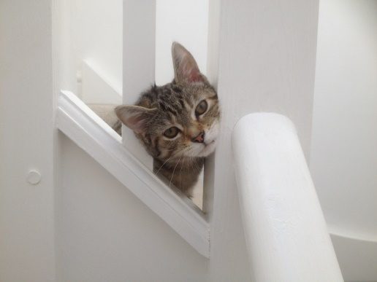**Exercise**

*Insert the most appropriate adjective into the space below:*

1) The new kitten was so cute and _______________.

2) The pain of her broken knee-cap was _______________.

3) Tom always helped people without ever expecting a reward; he was very _______________.

4) There was not enough sunlight in the tenement so the girl was _______________ in vitamin D, which made her bones weak and brittle.

5) The monkey was so _______________ that it could climb up the steep ravine effortlessly.

6) Henry’s bedroom was _______________ with books and toys everywhere.

7) Mr Fish’s Vienna trip was very _______________; only two hours.

8) Steve found the extra lessons very _______________ and he became top of the class.

9) The passengers became very _______________ as they had been stranded on the train for nearly three hours.

10) The Smith family had no money so they were compelled to lead a very _______________ lifestyle.

11) The general was in a _______________ mood as he refused to obey his superiors.

12) As the headmistress was so kind and _______________ to all her pupils, she was immensely popular.