**UNIT 15: The Environment**

Part 1: Describe the Picture

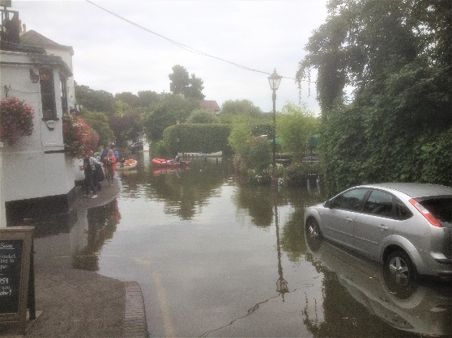

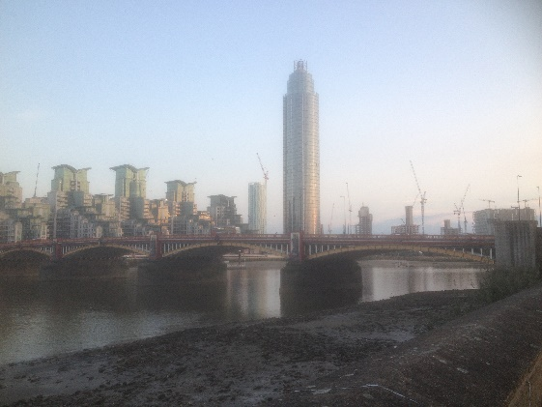

Part 2: Reading and Vocabulary

Global warming is destroying the environment. As sea levels rise, floods become more common. Global warming is caused by pollution from cars and factories. Countries nowadays try to control their emissions. One way people can cut their emissions is by having insulation in their homes such as double glazing. Some people have solar panels on their roof. These can also help cut household energy bills.

You can help the environment if you recycle cans, bottles and paper. Buying biodegradable products is also good for the planet as they break down naturally in the environment without causing pollution.

Part 3: Match the Vocabulary

|  |  |
| --- | --- |
|  | connected/related to the sun |
|  | making the air/water dirty |
|  | heating of the planet |
|  | large amount of water |
|  | use again |
|  | release of a gas |
|  | keeping warm |
|  | people who live together in a house |
|  | breaks down naturally |
|  | double window glass |

Part 4: Fill in the gaps with the correct form from the new words above

1) I have __________________ panels on the roof of my house.

2) ________ cans and bottles is easy to do.

3) Some plastic bags these days are _________.

4) _________ results in higher sea levels.

5) My __________ recycles all that it can.

6) __________ your home is a good way to help the planet.

7) Nowadays, many windows have ________.

8) Car and factory __________ are rising every year.

9) The air _________ in this town is much worse than it used to be.

10) Global warming results in more __________ in coastal areas.

Part 5: Ask and answer with your partner:

1) What sort of things can be **recycled** in your country?

2) How much of your waste do you recycle?

3) How popular is recycling in your country?

4) How important is the environment to you?

5) What do you think causes **global warming**?

6) What will the effects of global warming be?

7) What more do you think could be done to help the planet?

8) Is there much **pollution** where you live?

9) Has the environment become better or worse in your country?

10) What could your country do to lower its **emissions**?

11) How much does your **household** usually spend on energy bills?

12) Do you do anything to save energy?

13) Do many buildings in your country have **solar** panels?

14) Does the accommodation where you live have good **insulation**?

15) Is **double glazing** popular in your country?

16) Does your country often suffer from **floods**?

17) Do you ever use **biodegradable** products?

18) Do you have much nature in your country?

19) Do you believe in green taxes?

20) As flying is environmentally unfriendly, do you think air travel should be restricted?

21) Is there a green party in your country? Do they receive much support?

*Extension: write 4 questions about this topic to ask your partner.*

22)

23)

24)

25)

Part 6: Write the Questions to these Answers

1) ________________________________________________________________________?

Pollution is the main cause of global warming.

2) ________________________________________________________________________?

There are more floods because of global warming.

3) ________________________________________________________________________?

Breathing problems is one of the effects of pollution.

4) ________________________________________________________________________?

Emissions have risen by thirty per cent in my country this decade.

5) ________________________________________________________________________?

Insulation is good because it saves on energy bills.

6) ________________________________________________________________________?

Yes, double glazing is expensive.

7) ________________________________________________________________________?

Solar panels work best when it is sunny.

8) ________________________________________________________________________?

There are four members in my household.

9) ________________________________________________________________________?

In my country you can recycle paper, cardboard and bottles.

10)_______________________________________________________________________?

No, we don't have biodegradable bags in my country.